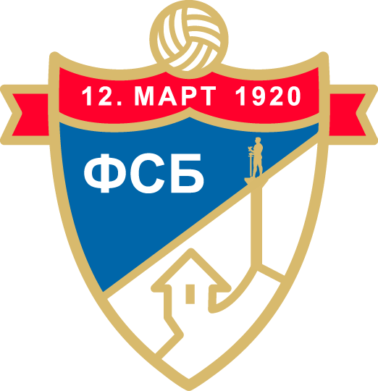

**ФУДБАЛСКИ САВЕЗ БЕОГРАДА**

**СПИСАК ПУТНИКА НА ТУРНИР Јосип Каталински 2010 год.**

|  |  |  |  |  |  |
| --- | --- | --- | --- | --- | --- |
| **Redni broj** | **Ime** | **Prezime** | **ЈJMBG** | **Klub/Funkcija** | **Pasoš** |
| 1 | Lazar | Perić | 3105010772025 | FK ČUKARIČKI | 015313035 |
| 2 | Uroš | Mlađenović | 2403010710213 | FK ČUKARIČKI | 017518189 |
| 3 | Nemanja | Mitrić | 2404010710031 | FK ČUKARIČKI | 018198231 |
| 4 | Nemanja | Trivić | 0707010710258 | FK ČUKARIČKI | 018199523 |
| 5 | Jovan | Milić | 1909010710148 | FK PARTIZAN | 017985368 |
| 6 | David | Stamenić | 1502010710234 | FK PARTIZAN | 018068697 |
| 7 | Uroš | Kikić | 2906010773616 | FK PARTIZAN | 016228326 |
| 8 | Viktor | Naumovski | 1311010710072 | FK ZEMUN | 017906584 |
| 9 | Maksim | Živojinović | 2001010710158 | FK CRVENA ZVEZDA | 017400472 |
| 10 | Petar | Mijušković | 1203010782831 | FK CRVENA ZVEZDA | 015515117 |
| 11 | Aleksa | Rajić | 2001010710026 | FK CRVENA ZVEZDA | 017310821 |
| 12 | Dušan | Vasiljević | 2812010710369 | FK CRVENA ZVEZDA | 017863687 |
| 13 | Ognjen | Petrović | 2706010710046 | RFK GRAFIČAR | 018196308 |
| 14 | Matija | Kalember | 0109010710075 | RFK GRAFIČAR | 018194982 |
| 15 | Novak | Marković | 0101010924988 | RFK GRAFIČAR | 017928756 |
| 16 | Andrija | Đurović | 1401010710217 | OFK BEOGRAD | 015768623 |
| 17 | Luka | Timotijević | 0201010710176 | OFK BEOGRAD | 017120052 |
| 18 | Mihajlo | Maksimović | 2111010710204 | PFK ŽARKOVO 2000 | 018196317 |
| 19 | Đorđe | Novakov | 1804010860038 | FK VOŽDOVAC | 016494409 |
| 20 | Vukan | Gavarić | 1404010710305 | FK VOŽDOVAC | 017722577 |
|  |  |  |  |  |  |
| St. štab | Dragoslav | Milenković | 1703976710260 | Glavni trener | 013811980 |
|  | Nemanja | Zlatković | 2108988860037 | Pomoćni trener | 017824702 |
|  | Marko | Jerotijević | 0610998710084 | Pomoćni trener | 012259890 |
|  | Nikola | Crnobrnja | 2301990710233 | Trener golmana | 016908588 |
|  | Nikola | Stefanović | 1606993710163 | Fizioterapeut | 010610290 |
|  | Milan | Bakić | 1012980710086 | Ekonom | 016865814 |
|  | Srđan | Milosavljević | 0209975710145 | Stručna služba FSB | 014401246 |
|  | Miloš | Mirković | 1306976710326 | Generalni sekretar | 013738761 |
|  | Ana | Jović | 1512984715301 | Komesar za takmičenje mlađ. kategorija | 016691743 |